3.5 W Gearbox Integrated Motor
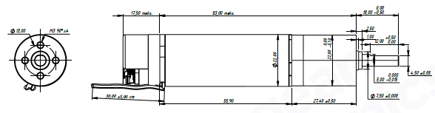
Basic Motor Parameters
Rated Power | W | 3.5
Rated Speed | rpm | 900
Rated Torque | Nm | 0.037
Rated Current | A | 0.50
Rated Voltage | V | 12
No-Load Speed | rpm | 1738
Max. Efficiency | % | 70
Electrical Parameters
Number of Phases |  | 3
Number of Poles |  | 6
Torque Constant (KT) | Nm/A | 0.063
Back EMF Constant (KE) | Vs/rad | 0.064
Terminal Resistance Phase to Phase (±%10) | mΩ | 8.32
Terminal Inductance Phase to Phase (±%30) | mH | 3.8
Thermal Data
Ambient Temperature | °C | -40...+85
Max. Winding Temperature | °C | +155
Physical Parameters
Outer Diameter | mm | 22
Shaft Diameter | mm | 5
Max. Lenght | mm | ~119
Weight | gr | ~193
Motor Connection
U | RED CABLE
V | WHITE CABLE
W | BLACK CABLE
Sensor Connection
1 | VDC+
2 | GND
8 | CLK-
9 | CLK+
10 | DATA-
11 | DATA+
Connector Articles
Power | 0.24MM^2 cable
Signal | Molex 501330-1100

